# SFRA Testing

Once the cartridge is installed and integrated based on instructions, please try to place an order

on your sandbox to test the storefront functionality.

Stripe test values can be found in the Stripe documentation (<https://stripe.com/docs/testing>).

This includes a number of test Credit Cards for use in testing a wide variety of scenarios.

However, the test Credit Cards only work while using your test secret and publishable API keys.

Further, you cannot use real Credit Card numbers with your test API keys.

Monitoring and testing the integration against the Stripe Dashboard is highly encouraged. Aside

from what Credit Card numbers can be used, Stripe functions largely the same with both test and

live transactions. Once you’ve satisfactorily completed and tested your integration, merely

change your two Stripe API keys to take your integration live.

## Checkout

Step 1: Add Product into cart.

Step 2: View the cart page or expand mini cart.

Step 3: Click on "Checkout" button.

Step 4: Checkout as Guest or login to your account.

Step 5: Fill shipping address or select shipping address from saved address and select shipping

method.

Step 6: Click on "Next: Payment" button.

Step 7: Fill billing address or select billing address from saved address, fill email, phone Number

and select payment method as "Credit card" and enter test data from https://stripe.com/docs/tes

ting or just use the card number 4242424242424242 and any CVV and expiration.

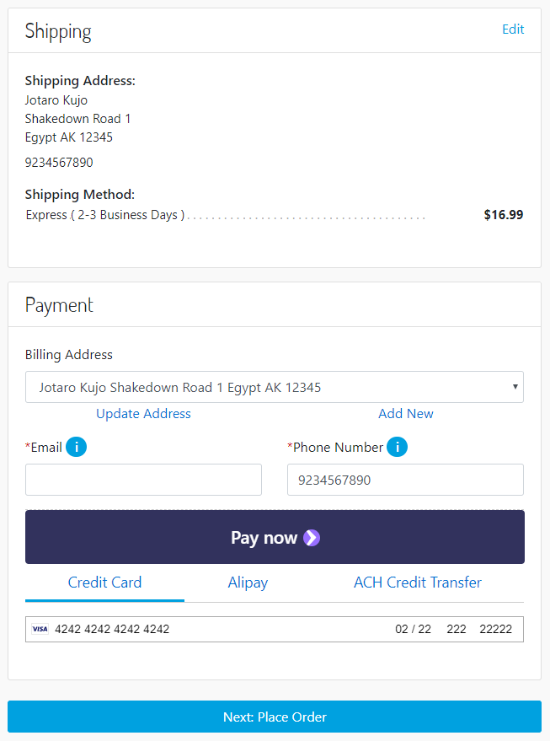

Step 8: Click on "Next: Place Order" button.

Step 9: You should see the confirmation page

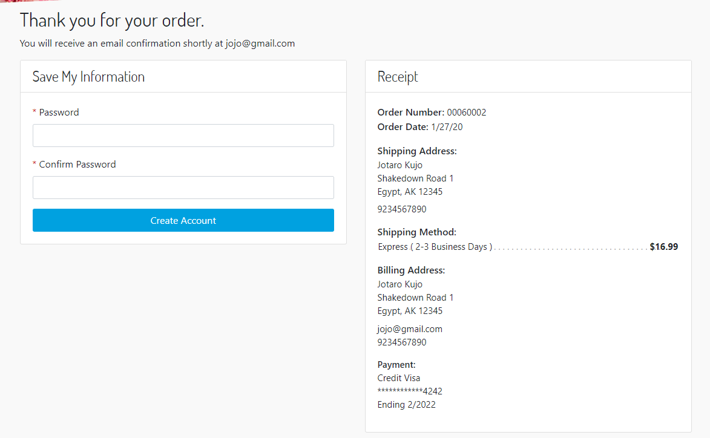

## Checkout using the Payment Request Button

Step 0: Make sure you have at least one saved address and one credit card in your browser

(Chrome)

Step 1: Add Product into cart.

Step 2: View the cart page or expand mini cart.

Step 3: Click on "Checkout" button.

Step 4: Checkout as Guest or login to your account.

Step 5: Fill shipping address or select shipping address from saved address and select shipping

method.

Step 6: Click on "Next: Payment" button.

Step 7: Click on "Pay now >" button

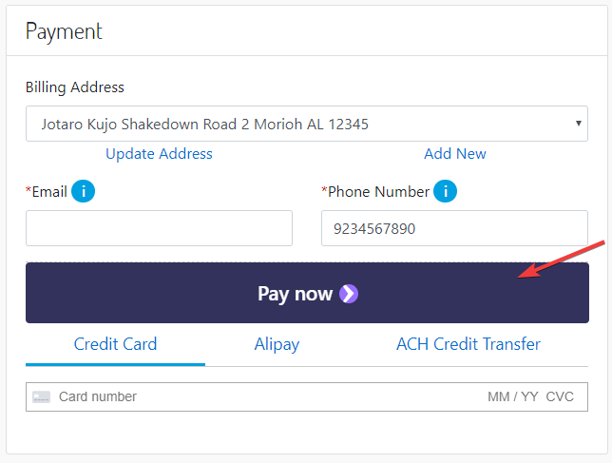

Step 8: A similar dialog should appear fill in the payment information and click the "Pay" button.

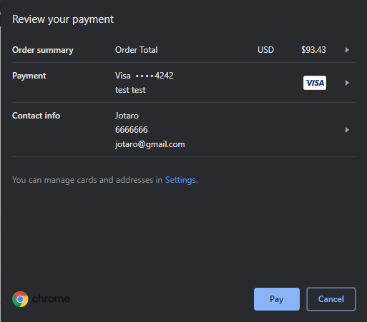

Step 9: Enter any CVC code and click confirm

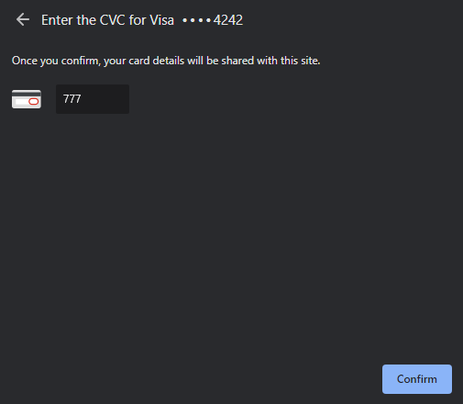

Step 10: After clicking confirm you should be redirected to the last page of the checkout. Click the

"Place Order" and you should see the confirmation page

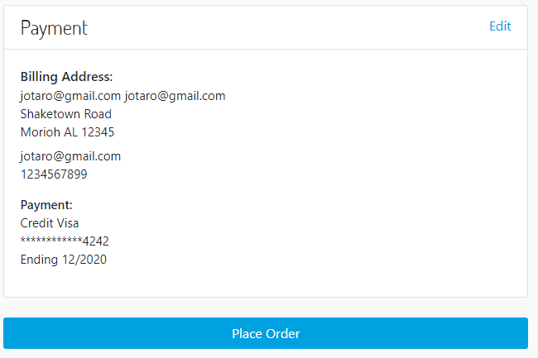

Step 11: The confirmation page should be visible

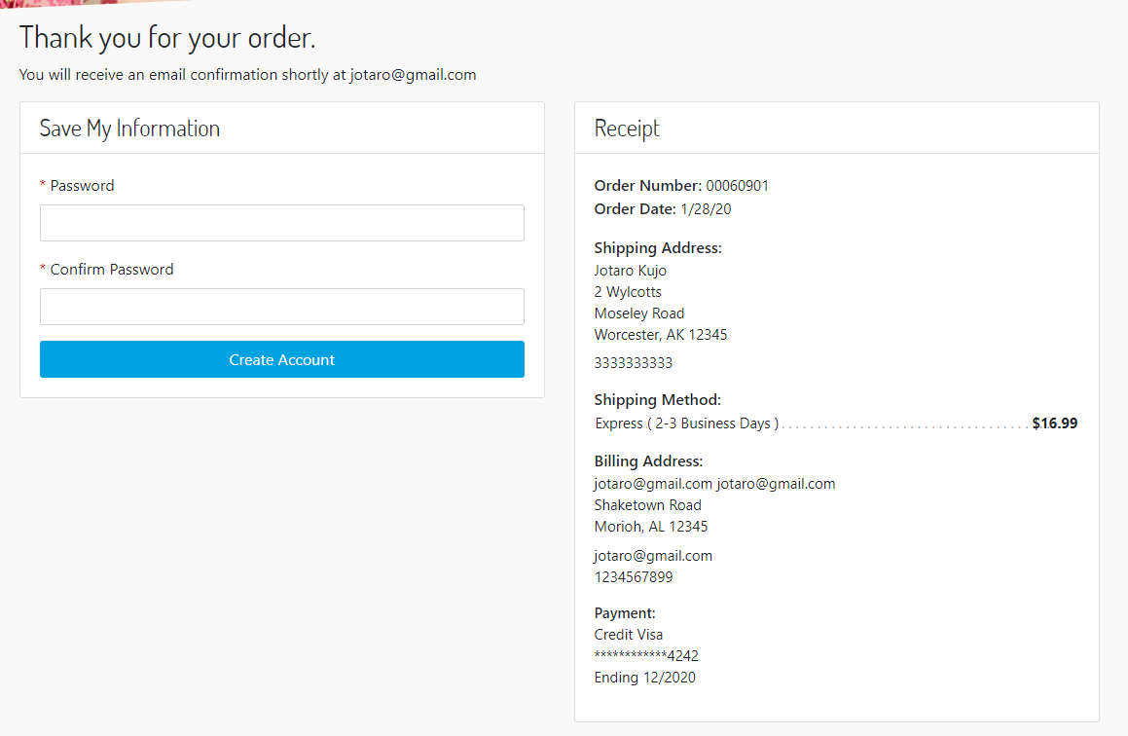

Controllers Testing

Once the cartridge is installed and integrated based on instructions, please try to place an order

on your sandbox to test the storefront functionality.

Stripe test values can be found in the Stripe documentation (https://stripe.com/docs/testing).

This includes a number of test Credit Cards for use in testing a wide variety of scenarios.

However, the test Credit Cards only work while using your test secret and publishable API keys.

Further, you cannot use real Credit Card numbers with your test API keys.

Monitoring and testing the integration against the Stripe Dashboard is highly encouraged. Aside

from what Credit Card numbers can be used, Stripe functions largely the same with both test and

live transactions. Once you’ve satisfactorily completed and tested your integration, merely

change your two Stripe API keys to take your integration live.

## Checkout

Step 1: Add Product into cart.

Step 2: View the cart page or expand the mini cart.

Step 3: Click on "Checkout" button.

Step 4: Checkout as Guest or login to your account.

Step 5: Fill shipping address or select shipping address from saved address and select shipping

method.

Step 6: Click on "Continue to billing" button.

Step 7: Fill billing address or select billing address from saved address, fill email, phone Number

and select payment method as "Credit card" and enter test data from https://stripe.com/docs/tes

ting or just use the card number 4242424242424242 and any CVV and expiration.

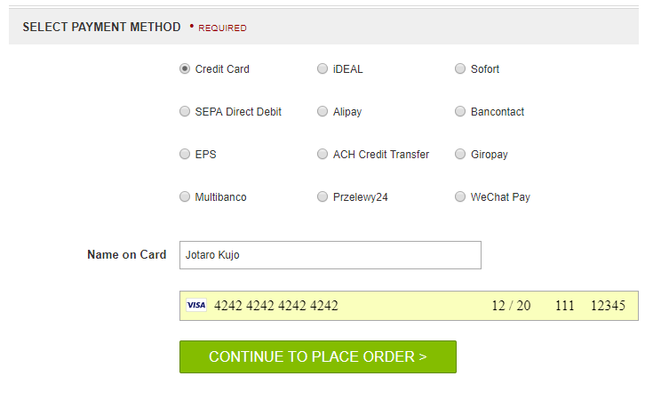

Step 8: Click on "Place order" button.

Step 9: You should see the confirmation page

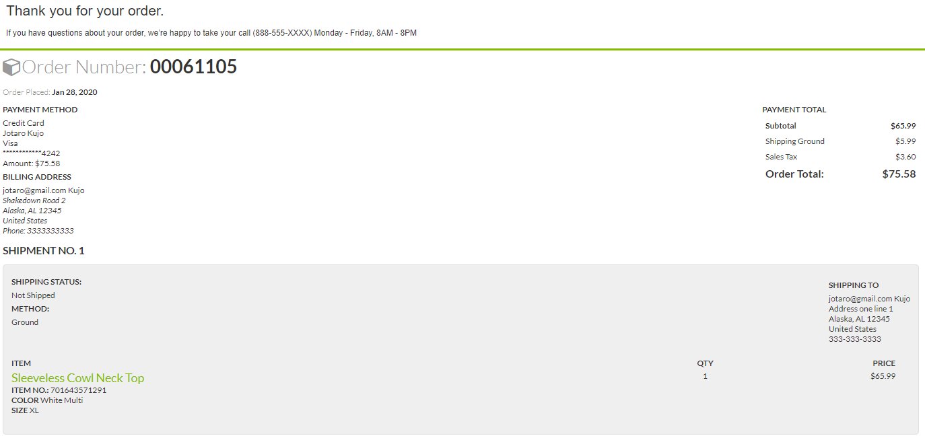

## Checkout using the Payment Request Button

Step 0: Make sure you have at least one saved address and one credit card in your browser

(Chrome) and that the STRIPE_PAYMENT_REQUEST_BTN payment method is enabled in BM

(Merchant Tools > Ordering > Payment Methods)

Step 1: Add Product into cart.

Step 2: View the cart page or expand mini cart.

Step 3: Click on "Checkout" button.

Step 4: Checkout as Guest or login to your account.

Step 5: Fill shipping address or select shipping address from saved address and select shipping

method.

Step 6: Click on "Next: Payment" button.

Step 7: Click on "Pay now >" button

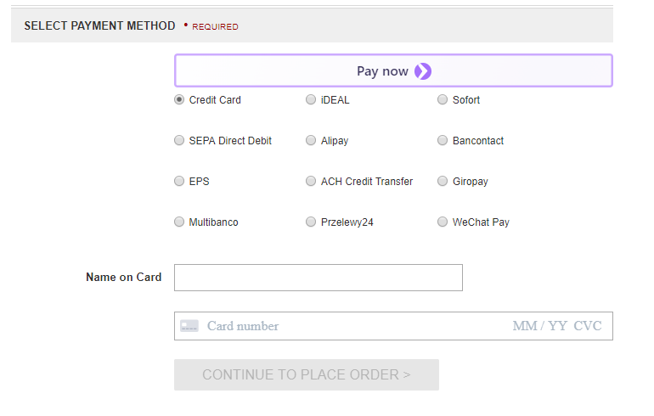

Step 8: A similar dialog should appear fill in the payment information and click the "Pay" button.



Step 9: Enter any CVC code and click confirm



Step 10: After clicking confirm you should be redirected to the last page of the checkout. Click the

"Place Order" and you should see the confirmation page

Step 11: The confirmation page should be visible

